Thy Kingdom Come
Thursday 25 May – Friday 2 June

Novena Centering Prayer
An ecumenical gathering for 7 days between Ascension and Pentecost
to learn a silent prayer practice.

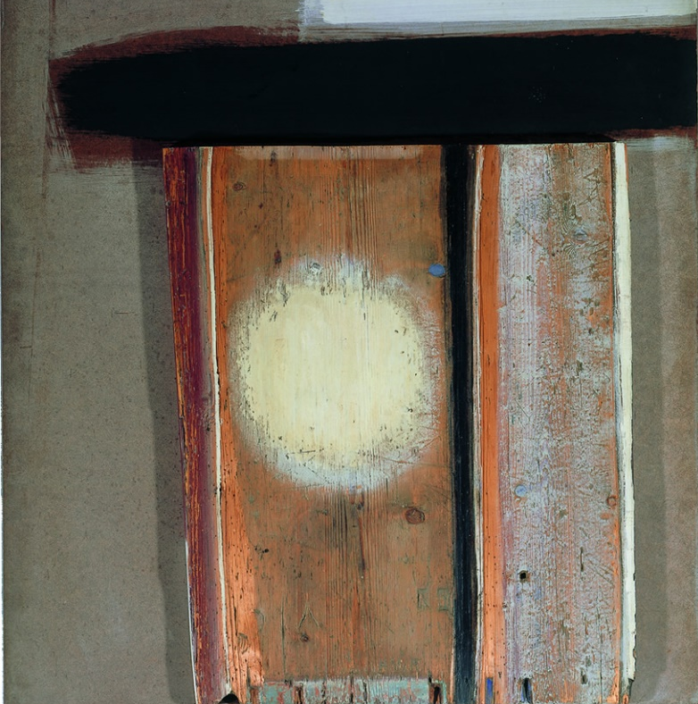
Pentecost by Dennis Hawkins (1925-2001) Oil on wood (old school desk) 1962
Methodist Modern Art Collection

Learn or deepen a practice of silent centering prayer, in the weekdays between Ascension and Pentecost.
This is a transformative meditation practice for those wanting to find God in their depths.
It is a prayer of learning to wait in the deepest part of yourself, through an intentional letting go of thoughts, allowing the mind to descend to the heart.
Learn with others and begin to notice the fruits in a freer more spacious sense of everyday living. Come as often as you can (some days or everyday).

DATES: Thursday May 25th; 26th, 29th, 30th, 31st, June 1st and Friday 2nd.
TIMING: 8.50 for 9 am start. Finish 9.30
VENUE: St Mary’s Church, Overton, meeting in the chancel (choir stalls)
More information: Revd Jenny Ellis jenny.battsrow@gmail.com 01256 892 895 or
Revd Ian Smale iansue.smale@btinternet.com 01256 770207

