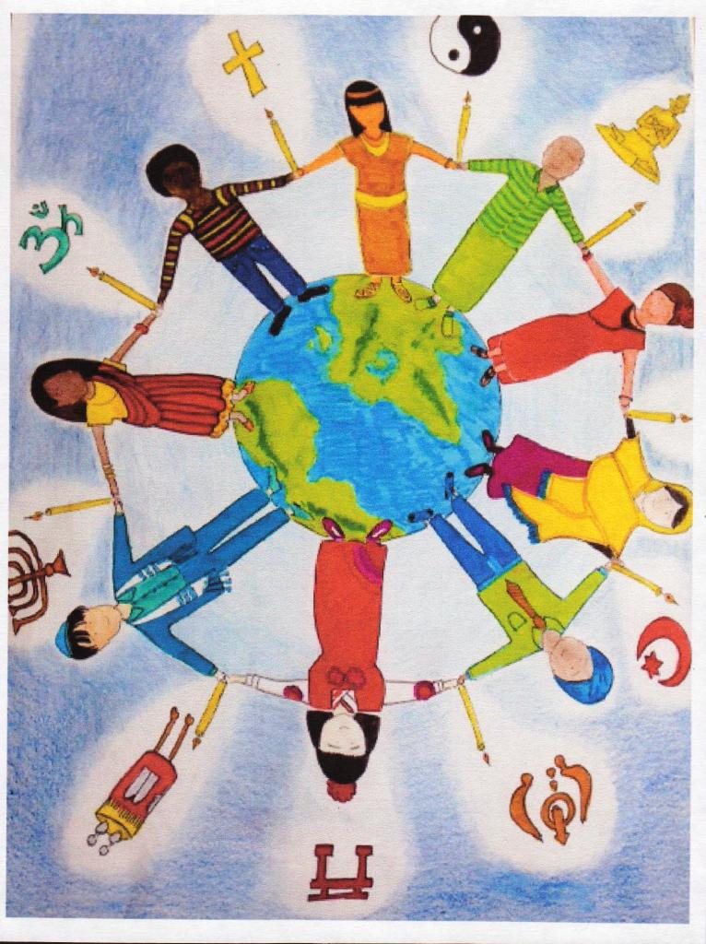

Do join us as we join in prayer with our link

and they pray for us.

A short time of prayer, followed by tea and coffee.

A time to pray with our brothers and sisters in Kinkiizi Diocese Uganda